**Coding Assignment 5**

***Shubham Maheshwari(17EC10055)***

For Image 1:

|  |  |  |  |
| --- | --- | --- | --- |
| ***MMSIM Values*** | ***Corrupted Img*** | ***Median Filtered*** | ***Alpha Trimmed Mean Filtered*** |
| **Gaussian** | 0.5178 | 0.6708 | 0.6843 |
| **Blurred** | 0.8898 | 0.8744 | 0.8222 |
| **Laplacian** | 0.4599 | 0.6866 | 0.6714 |

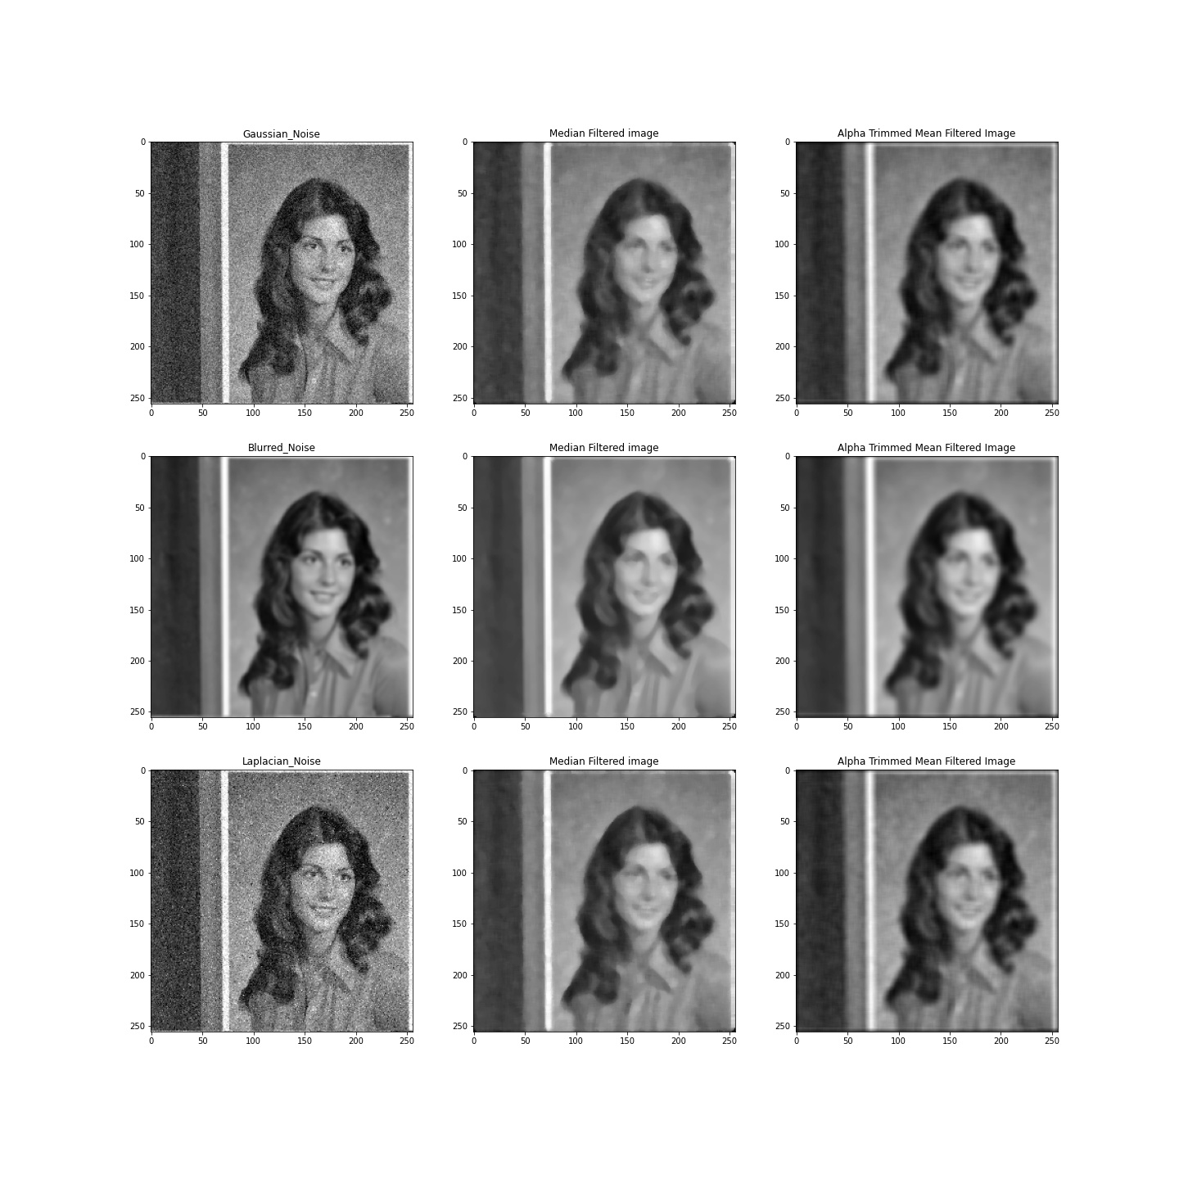

For Image 2:

|  |  |  |  |
| --- | --- | --- | --- |
| ***MMSIM Values*** | ***Corrupted Img*** | ***Median Filtered*** | ***Alpha Trimmed Mean Filtered*** |
| **Gaussian** | 0.5552 | 0.7092 | 0.7281 |
| **Blurred** | 0.9122 | 0.9025 | 0.8688 |
| **Laplacian** | 0.5075 | 0.7215 | 0.7144 |

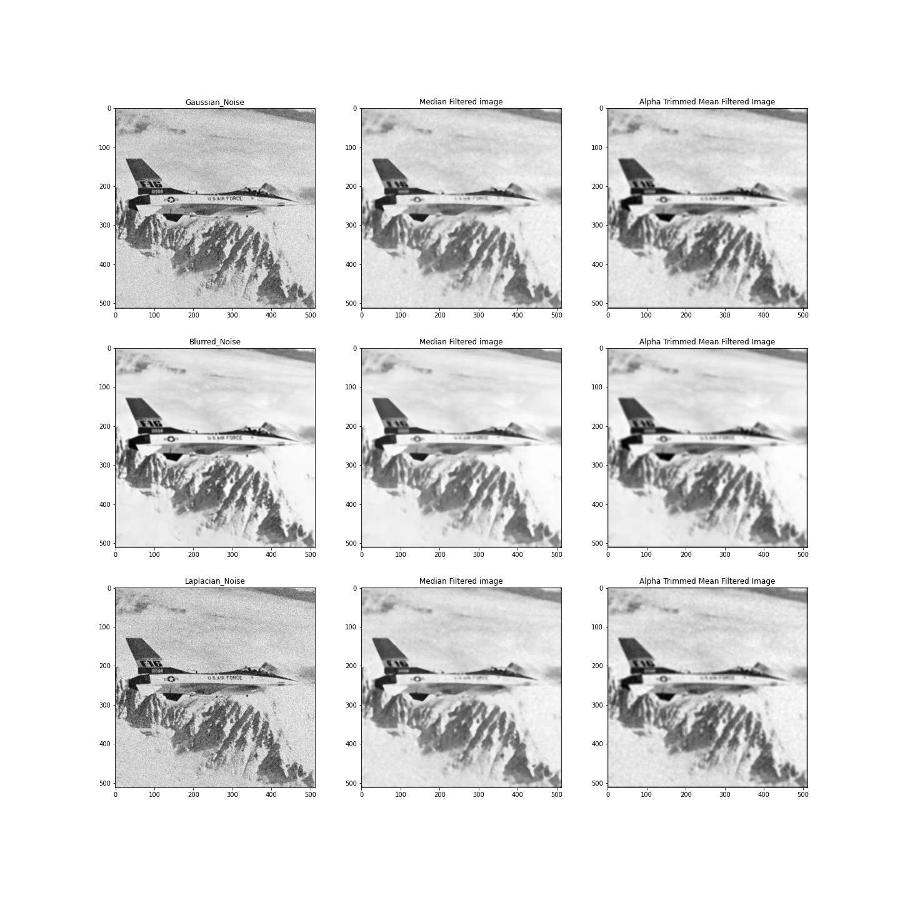

For Image 3:

|  |  |  |  |
| --- | --- | --- | --- |
| ***MMSIM Values*** | ***Corrupted Img*** | ***Median Filtered*** | ***Alpha Trimmed Mean Filtered*** |
| **Gaussian** | 0.6642 | 0.8232 | 0.8390 |
| **Blurred** | 0.9258 | 0.9218 | 0.9069 |
| **Laplacian** | 0.5964 | 0.8300 | 0.8249 |

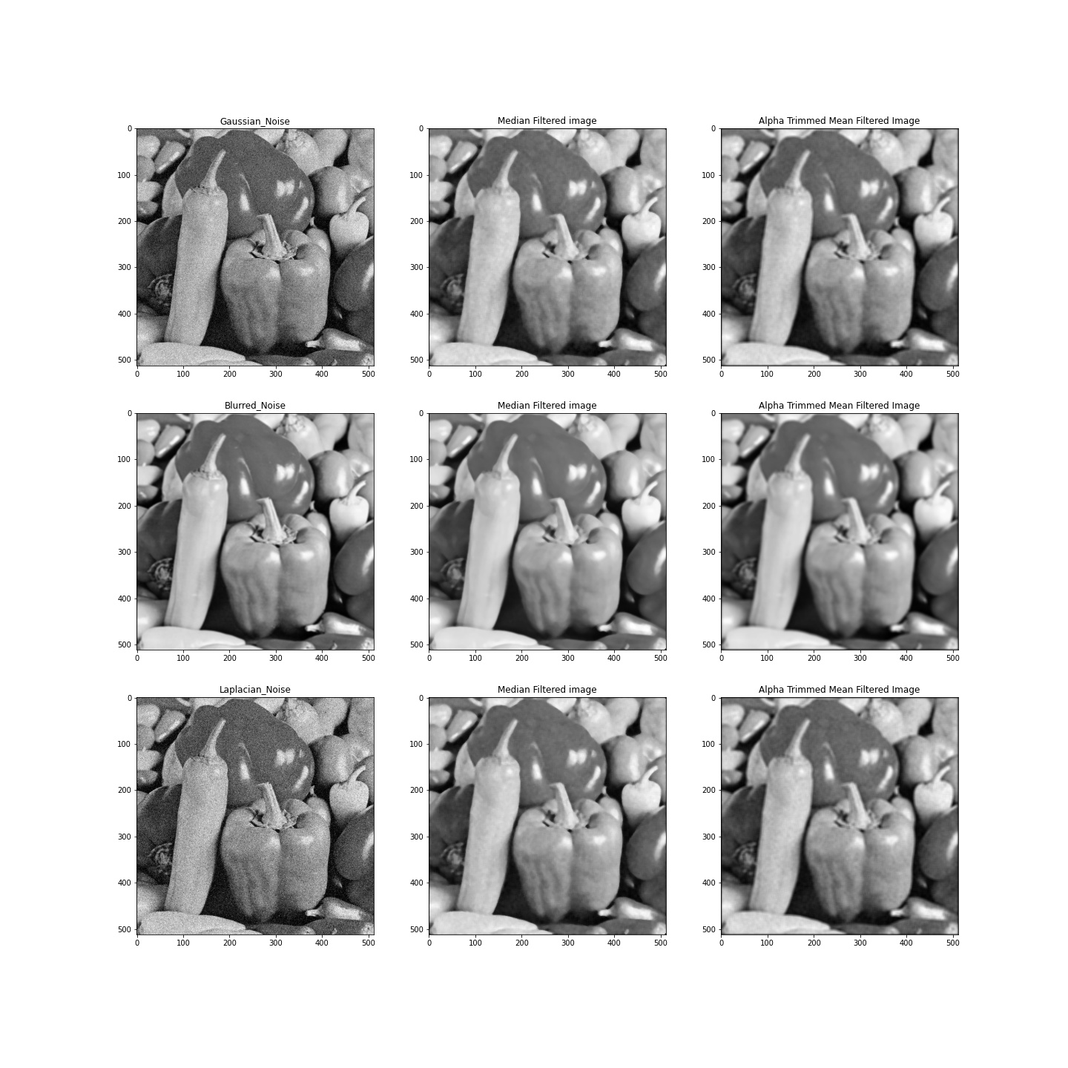

**DISCUSSION**

* The two types of filters used were Median order statistic filter and alpha-trimmed mean order statistic filter.
* Alpha-trimmed mean filter is based on order statistics and varies between a median and a mean filter. It is used when an image contains both short and long tailed types of noise (e.g. both Gaussian and salt and pepper noise).
* Alpha-trimmed mean filters are widely used for the restoration of signals and images corrupted by additive non-Gaussian noise. They are especially preferred if the underlying noise deviates from Gaussian with the impulsive noise components.
* Median Filter is excellent for noise removal, without the smoothing effects that can occur with other smoothing filters. It gives the best result when aimed at removing salt and pepper noise.
* It can be observed that MSSIM is not a good metric to differentiate blurred images from the uncorrupted ones. Neither of the filters were able to achieve better similarity score in case of blurred images.
* The images restored from Laplacian noise corruption were a great improvement on their corrupted counterparts due to the reason that Laplacian noise resembles salt and pepper noise closely. The best results were obtained using the median filter as expected.
* For images corrupted by Gaussian noise, it was observed that the alpha-trimmed mean filter performed better restoration than the median filter.
* A kernel size of 1 was used for both the filters. In case of alpha trimmed mean filter, trim = 1 was used.